**FOR IMMEDIATE RELEASE**

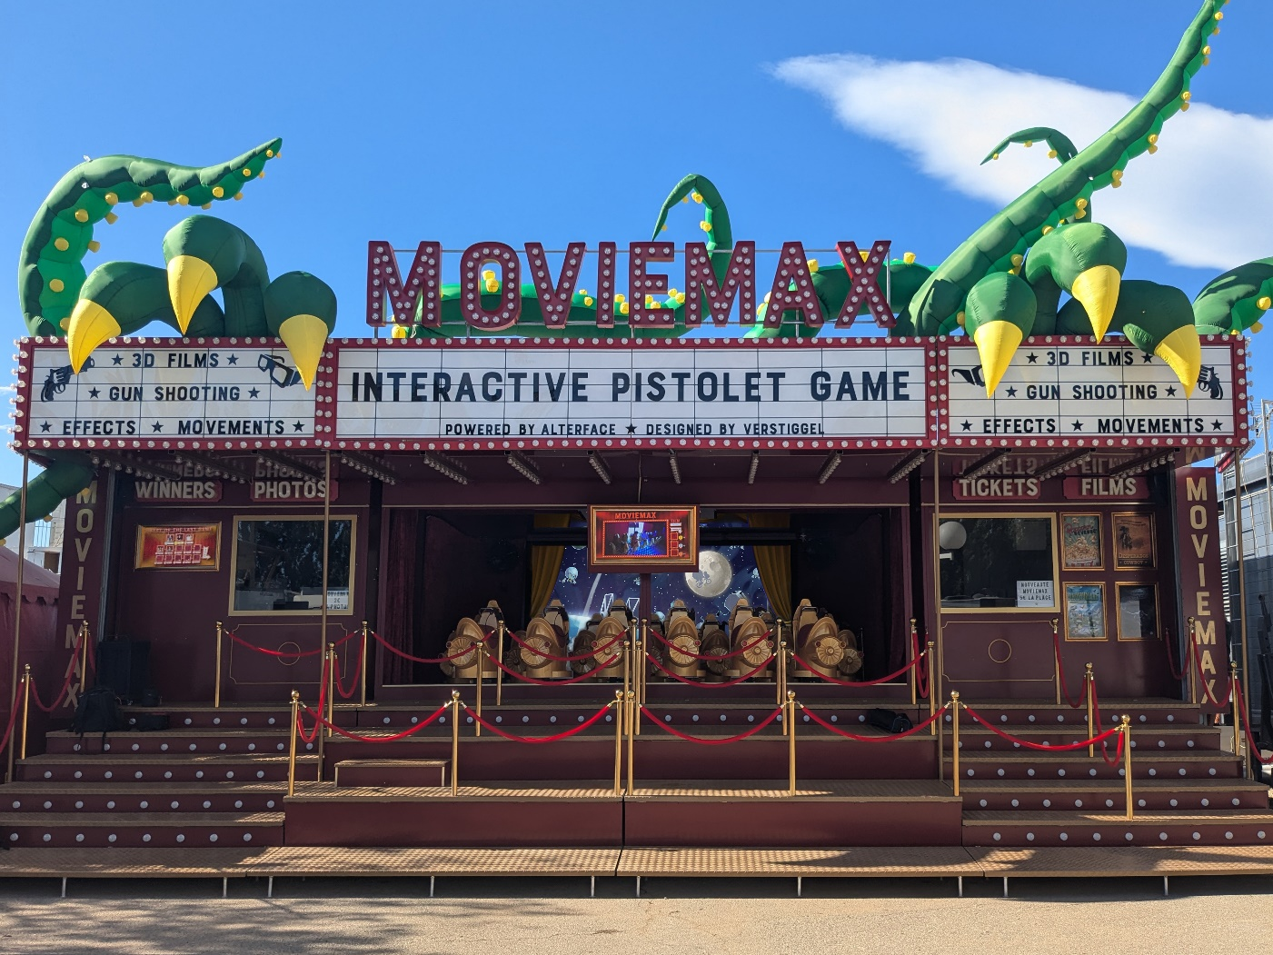**Moviemax powered by Alterface takes interactive screen adventures on the road.**

**Wavre, Belgium, September 3, 2024** - Powered by Alterface interactive technologies, Moviemax, a breakthrough compact and transportable attraction, revolutionizes guest experiences at fairs and itinerant events. “Conceived and designed by seasoned showman Léo Verstiggel to meet the unique requirements of traveling fairs, Moviemax showcases our teams’ ability to tailor entertainment solutions for varied client demands,” says Stéphane Battaille, CEO of Alterface. “Compact, transportable, offering unique theming, interactive action, feature content suitable for all ages and a competitive initial price point, Moviemax sets a new standard for a unique and successful traveling attraction.”

The first Moviemax transportable interactive screen adventure opened for players in late June at Azur Park in St-Tropez. With its first summer season an unqualified success, Verstiggel is more excited than ever about Moviemax. “Collaborating with Alterface was a wonderful experience. Their interactive technology brought my vision for a vintage cinema carousel to life,” he says. “Together, we created an attraction that honors my family’s legacy and brings highly interactive entertainment to fairs and events.”

Drawing on four generations of showmen, Verstiggel’s ingenious design is contained within a readily transported by road, rail and sea 40-foot container that transforms in less than three hours into a fully-themed 90 M2 set designed to entice visitors and reap profits. The attraction boasts hundreds of classic light bulbs, iconic marquee signs, ticketing, photo booth, queue line, and motion-based seats for thirteen players at a time. Its rapid setup and minimal operator demands translate into lower operational costs.

Moviemax offers four different films—Popcorn Revenge, Desperados Cowboy, Dinosaurland, and Zombie Attack!!!—catering to a broad range of audiences from families and young children to teenagers. Each film is energized by Alterface technologies, engaging players within an interactive and 3D experience never before offered at fairs and itinerant events. Moviemax incorporates a range of special effects—wind, water, stroboscopes, smoke, motion—to create an immersive traveling experience never before available to this market segment.

“Whether interested in acquiring a Moviemax for your show or desiring a bespoke attraction of your own design, Alterface is ready to meet your needs,” says Battaille. “Our successful projects are entertaining people in new and exciting ways the world over. Equally important, attractions like Moviemax are meeting a wide range of operator needs and demands. Give us a call. We’d love to chat.”

**About**

Founded in 2001 as a spin-off of the University of Louvain-la-Neuve (UCL), Alterface provides both technology and turnkey solutions for the interactive attractions industry. Their technology and one-stop turnkey solutions for media-based interactive dark rides and attractions in theme parks have made Alterface a worldwide market leader. They offer a unique combination of technical specialists and creative talents working relentlessly together to create never seen before guest’s experiences.  
More: [www.alterface.com](http://www.alterface.com)

Contact: Giulia Florian, Alterface

Marketing Communications Manager  
[+32 483 09 98 80](tel:+32+483+09+98+80)    
giulia.florian@alterface.com