**FOR IMMEDIATE RELEASE**

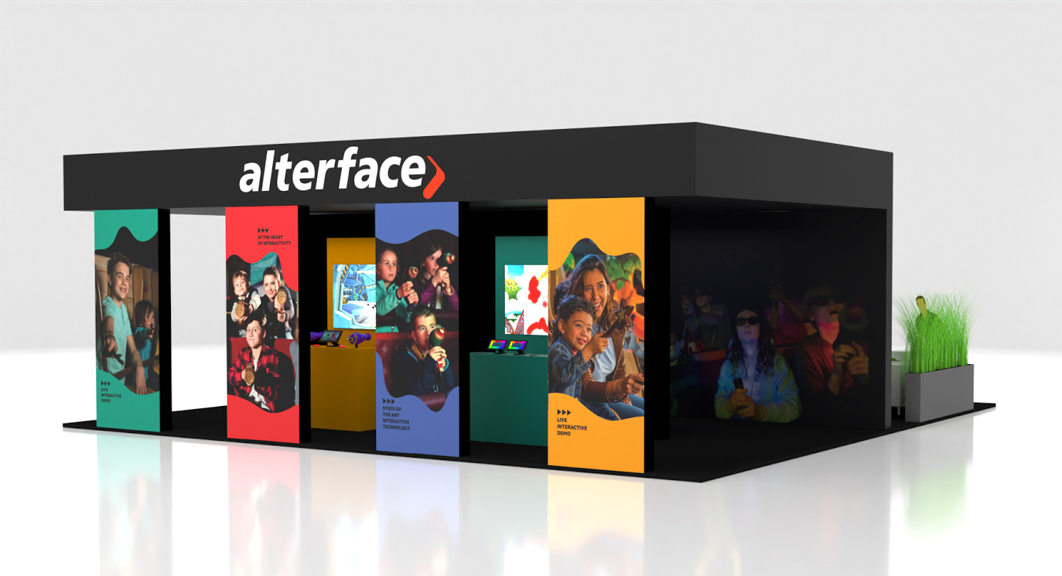**Alterface offers IAAPA attendees a firsthand taste of tomorrow's interactive experiences**

**Wavre, Belgium, October 29, 2024** - “The Alterface Imagination Playground is designed to challenge established ideas of what interactive attractions can be,” says Stéphane Battaille, CEO of Alterface. He’s referring to the custom-built demonstration space being crafted by Alterface for attendees of IAAPA Expo in Orlando (November 19-22, 2024). Located in Alterface’s booth (#1083), the Imagination Playground will feature four stations for guests to experience new applications of Alterface’s signature interactive technology. While many themed gaming systems are centered around shooting, the Alterface team is bringing to the trade show floor new options for gameplay that broaden the concepts of interactivity and immersion. Each station will offer a brief experience showcasing how the technology might be integrated into a larger attraction.

“As experts in interactive technologies for themed entertainment we are excited to share our latest concepts in the Alterface booth during IAAPA Expo,” says Battaille. “We invite designers, owners and media producers to reserve a VIP tour of the Imagination Playground in advance by emailing communication@alterface.com*.”*

The four stations in Imagination Playground offer unique gameplay created from conversations with Alterface clients and are designed to inspire industry creatives to push the boundaries of traditional interactive attraction design. “Because of our decades of experience, we know that partnering with designers and operators early on in the process can lead to amazing results,” says Battaille. “By understanding the vision for their guest experience, we can better craft solutions that help them to differentiate their attractions within the marketplace.” Each of the Imagination Playground stations was designed with that focus on differentiation in mind.

Guests will enjoy the following unique gameplay experiences:

· **Paint -** A magic wand helps unveil your inner artist as you splash color across the virtual canvas.

· **4D Shooter -** Compete against your friend, pull the shooting cord, activate the targets and win!

· **Trace -** Grab a wand and connect the stars to reveal special shapes and constellations.

· **Illuminate -** Use the special flashlight to explore a scene, discover surprises and avoid dangers.

“With over 20 years of developing, refining, and advancing interactive technology through constant prototyping and testing, we are excited to bring our hands-on approach directly to the show and to the design community,” explains Battaille. In addition to the Imagination Playground demos that showcase the guest-facing experience, Alterface will be sharing information on updates to the technology that powers their attractions, including a new software suite and service package. Alterface’s services also include in-depth consultation and guidance, assisting designers throughout the process - from concept to implementation.

“Alterface creates the toolbox of technology that supports the creation of amazing immersive attractions,” affirms Battaille. “The Alterface Imagination Playground at IAAPA Expo will provide the perfect opportunity for creatives to hold our technology in their hands, play with these tools and work with us to create the interactive experiences of tomorrow.”

Alterface’s Imagination Playground will be available throughout the trade show, but space is limited and attendees are encouraged to **reserve** **a time for a personalized visit in advance by emailing** [**communication@alterface.com**](mailto:communication@alterface.com)

Additionally, **a press conference will be held at Alterface booth #1083 on November 20th at 11:40 AM**, where attendees will gain exclusive insights into Alterface’s state-of-the-art interactive technology and the many possibilities it can offer.

**About Alterface**:  
Founded in 2001 as a spin-off of the University of Louvain-la-Neuve (UCL), Alterface provides both technology and turnkey solutions for the interactive attractions industry. Their technology and one-stop turnkey solutions for media-based interactive dark rides and attractions in theme parks have made Alterface a worldwide market leader. They offer a unique combination of technical specialists and creative talents working relentlessly together to create never seen before guest’s experiences.

Visitors can enjoy Alterface rides at PortAventura World, Hersheypark, Warner Bros. World, Six Flags, Walibi Belgium, Legendia, Qingdao Wanda, Jardin d’Acclimatation, Phantasialand, LEGO® Discovery Centers, Cedar Fair, Carowinds, Ferrari World, IMG, Lotte World, Yumiyuri land, Lost Island and many more. The company has received several Thea Awards for Outstanding Achievement as well as multiple other industry honours including Brass Ring Awards and Park World Excellence Awards.

More: [www.alterface.com](http://www.alterface.com)

Contact:

Giulia Florian  
Marketing Communications Manager  
[+32 483 09 98 80](tel:+32+483+09+98+80)    
giulia.florian@alterface.com