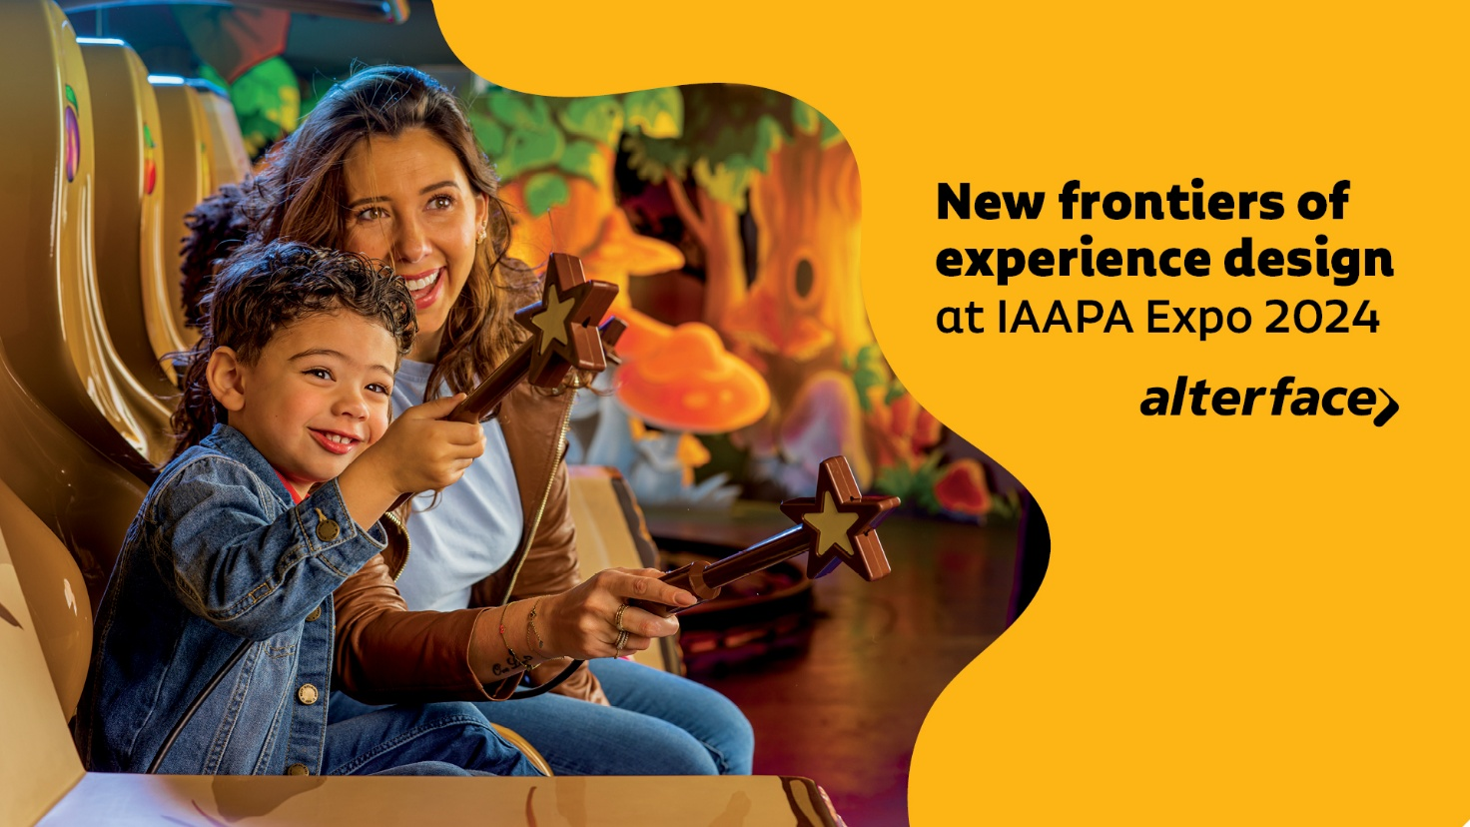**FOR IMMEDIATE RELEASE**

**Global interactive tech leader Alterface opens new frontiers  
of experience design at IAAPA Expo 2024***New service packages support clients in crafting innovative interactive experiences*

**Orlando, November 21, 2024** - “With the introduction of our new service packages at IAAPA Expo 2024, Alterface is bringing the power to engage guests with interactive technology, cutting-edge experience design and immersive storytelling within the reach of more operators, producers and creatives,” says Alterface CEO Stéphane Battaille.

Alterface, a global leader in interactive experiences and immersive entertainment serving the attractions industry for two decades, is exhibiting its new offerings at IAAPA Expo in booth #1083. The booth, nicknamed Alterface’s Imagination Playground, offers a series of demos highlighting Alterface’s constant innovation and commitment to client collaboration while showcasing their new, versatile service packages.

Designed to help integrate the company’s latest technology and tools for immersive experiences, dark rides and walkthroughs, Alterface’s new service packages provide options to support the experience design process from concept to completion and beyond.

**New service packages enhance client collaboration**

Customizable options in the realm of gameplay design, prototyping, technical support, and ongoing maintenance help ensure clients can select the right Alterface services for their unique projects. “By integrating our services during the design stage, clients can benefit from the company’s holistic approach, developed to ensure seamless interactivity with the entire experience,” says Battaille.

Alterface created its new prototyping service to take the guesswork out of attraction design. “We work directly with designers to determine the ideal experience for guests and then develop or modify the perfect technology to achieve that,” says Battaille. Thorough testing, validation and a collaborative, iterative process help ensure the best solutions are implemented.

For clients just beginning the process of creating an attraction, Alterface offers interactive concept design, integrating interactivity from the very start into the many complex systems and elements. Successful attraction storytelling is built on the flawless connection between many dynamic systems, and Alterface’s concept design services focus on bringing those elements together in a thoughtful and consistent way before a project moves into production.

**An expanded range of cutting-edge tools**

These new service options are supported by several advanced tools designed to make creating and operating an interactive attraction even easier. “We’re continually expanding the range of tools available and honing our proven technology for ever greater efficiency and next-generation experiences,” says Battaille. “This is why Alterface continues to be a reliable choice for interactive technology solutions.”

Among Alterface’s latest tools are the **CartBox system** whichoffers an onboard controller for ride vehicles that supports an infinite array of interactive devices as well as audio feedback systems, creating highly customizable and synchronized soundscapes.

The **GunBox system** streamlines maintenance and calibration, allowing operators to test and adjust interactive systems with efficiency and ease, even during operational hours. Additionally, Alterface’s technical backbone has been upgraded with **virtual machine** technology, improving system efficiency while providing additional redundancy and superior reliability, resulting in minimized costs and a more sustainable environmental impact.

**Interactive at the core**

These offerings reflect the Alterface dedication to collaboration and co-creation, and its continuous investment in innovation and R&D, all with the core goal of authentic, engaging and interactive guest experiences that resonate with audiences.

“At Alterface, interactivity isn’t an add-on - it’s the core of the experience. Interactivity actively engages guests and immerses them in the story. Our goal is to ensure that interactivity is seamlessly integrated across all elements from the very beginning of the project,” says Battaille. “We believe our approach opens up exciting new possibilities for the industry and represents an unprecedented, new level of service. The potential applications are vast, and we’re eager to collaborate with visionary clients to bring these concepts to life.”

**About Alterface**:  
Founded in 2001 as a spin-off of the University of Louvain-la-Neuve (UCL), Alterface provides both technology and turnkey solutions for the interactive attractions industry. Their technology and one-stop turnkey solutions for media-based interactive dark rides and attractions in theme parks have made Alterface a worldwide market leader. They offer a unique combination of technical specialists and creative talents working relentlessly together to create never seen before guest’s experiences.

Visitors can enjoy Alterface rides at PortAventura World, Hersheypark, Warner Bros. World, Six Flags, Walibi Belgium, Legendia, Qingdao Wanda, Jardin d’Acclimatation, Phantasialand, LEGO® Discovery Centers, Cedar Fair, Carowinds, Ferrari World, IMG, Lotte World, Yumiyuri land, Lost Island and many more. The company has received several Thea Awards for Outstanding Achievement as well as multiple other industry honours including Brass Ring Awards and Park World Excellence Awards.

More: [www.alterface.com](http://www.alterface.com)

Contact:

Giulia Florian  
Marketing Communications Manager  
[+32 483 09 98 80](tel:+32+483+09+98+80)    
giulia.florian@alterface.com