**FOR IMMEDIATE RELEASE**

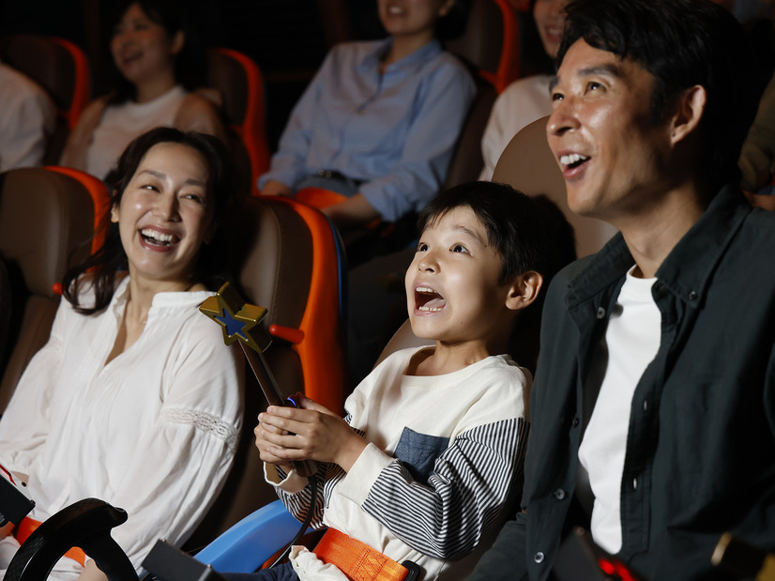**Cinnamoroll’s Little Big Adventure in Puroland Flies High with Alterface Technologies**

**Wavre, Belgium, September 11, 2024** - Alterface technologies have united the iconic Cinnamoroll character with adoring fans at the Discovery Theater in Sanrio Puroland theme park in Tokyo. Cinnamoroll is famous for endearing and inspirational quotes, many of which carry deep meanings about the importance of friendship, kindness and never giving up on your dreams. In a first for Asia, a pair of synchronized theaters offer interactive game play and special effects for guests as they embark on **Cinnamoroll’s Little Big Adventure**, a 5-minute romp through the sky chasing rainbows and overcoming obstacles together.

“This is Puroland park’s first new attraction in more than a decade,” says Stéphane Battaille, CEO of Alterface. “It is a delightful story-based ride with audience engagement at key moments that asks and answers several questions: Why is a rainbow so beautiful? What is it made of? The adventure creates a strong emotional connection between the guests, the lovable game characters and this sense of wonder.”

The gameplay in *Cinnamoroll’s Little Big Adventure* strikes a perfect balance between storytelling and interactive engagement. While there is a competitive element that encourages guests to use their Magic Star Wands to overcome obstacles, the focus remains on the narrative journey rather than pure shooting mechanics. This approach ensures that the emphasis stays on the emotional connection and the unfolding adventure, allowing guests to immerse themselves fully in the story while still enjoying moments of friendly competition.

Each of the two theatres boasts 35 motion-based seats, including two spaces designated for wheelchairs and a front-of-house bench for small children. Interactive opportunities and special effects create an exciting experiential environment as guests team up with Cinnamoroll and his companions in their quest for rainbows. As the ride progresses, guests become essential helpers with their Magic Star Wands, targeting a series of obstacles. Scores for effectiveness with the devices are kept at each seat, and the most accurate helpers are rewarded with their faces projected on the theatre screen at the end of the experience.

This dual theatre approach offers many advantages, from providing unique, interactive guest experiences and a huge capacity of 600+ person per hour throughput within a compact location, from maximizing staff utilization and ensuring a good return on investment.

“Believe in yourself and anything is possible, Cinnamoroll has told his fans,” says Battaille. “At Alterface we believe in making any interactive experience possible. Every IP character deserves to be brought to life for their fans. Our team and our patented technologies has made that happen for Sanrio and Cinnamoroll through this unique dual screen approach to entertaining and engaging guests. We can’t wait for our next challenge.”

**About Alterface:** Founded in 2001 as a spin-off of the University of Louvain-la-Neuve (UCL), Alterface provides both technology and turnkey solutions for the interactive attractions industry. Their technology and one-stop turnkey solutions for media-based interactive dark rides and attractions in theme parks have made Alterface a worldwide market leader. They offer a unique combination of technical specialists and creative talents working relentlessly together to create never seen before guest’s experiences. More: [www.alterface.com](http://www.alterface.com)

Contact: Giulia Florian, Alterface

Marketing Communications Manager  
[+32 483 09 98 80](tel:+32+483+09+98+80)    
giulia.florian@alterface.com